The Retrograde Motion of Mars

Kate Mackrell, February 2009
katemackrell@sympatico.ca

Facts to consider: (taken from http://nssdc.gsfc.nasa.gov/planetary/factsheet/marsfact.html

Radius of orbit relative to Earth: 1.524
Orbital velocity relative to Earth: 0.810
Orbital inclination: 1.85 degrees

1. Let’s start by using the Circle tool to make a circle in the base plane with centre the origin. This will model the path of the earth around the sun
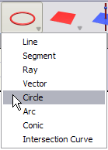

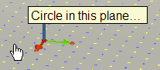

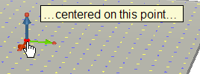

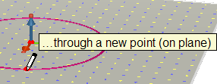

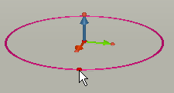

2. Repeat this to create another, larger circle.
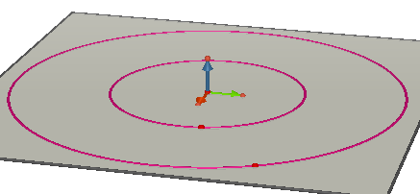

3. We will now create another circle that will enable us to tilt this bigger circle relative to the smaller one.
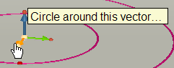
MAKE SURE THIS IS WHAT THE TOOLTIP SAYS BEFORE CLICKING
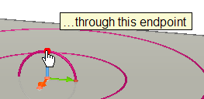

4. Now use the Point tool to put a point on this circle.
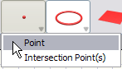

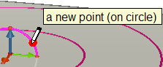

5. Use the Angle tool to measure the angle defined by this point, the origin, and the tip of the green vector.
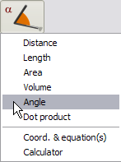

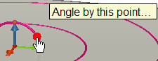

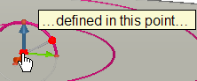

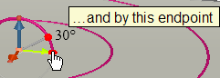

6. We will now use the Rotation tool to rotate the larger circle by this angle about the red base vector.
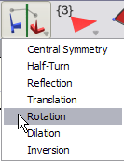

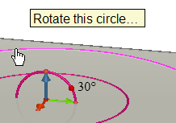

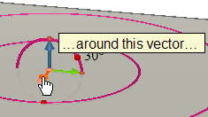

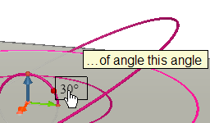

7. Now let’s use the Point tool to put points on the circles to represent Earth and Mars.
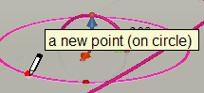
DO NOT CHOOSE THE RADIUS POINT OF THE CIRCLE.
Type EARTH immediately after clicking to label the point. Repeat to place MARS on the inclined circle
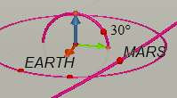

8. Let’s now set them in motion. Use the Pointer or Manipulation tool to select the point Earth
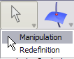
Now click on point Earth.
Use the Window-Animation menu to get out the Animation panel.
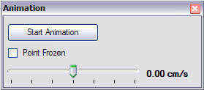

Set the speed and click on the button to start animation.
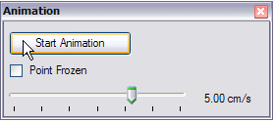

Click to stop the animation and then repeat for MARS, with a different animation speed.
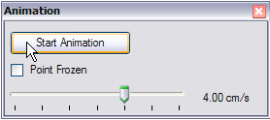

Both points should now be in motion, at different speeds.
9. Let’s now model the appearance of MARS from EARTH. To represent the line of sight of an observer on Earth, use the Ray tool to draw a ray from EARTH through MARS.
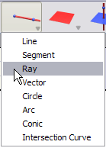

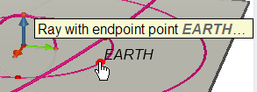

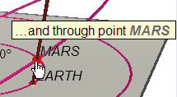

10. The observer on Earth will see Mars move relative to the background of “fixed” stars. Let’s use the Sphere tool to model this background.
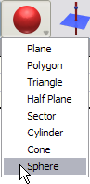

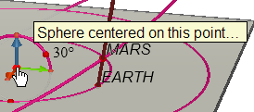

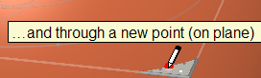

Let’s change the appearance of this sphere – an opaque sphere is not a lot of use! Select the sphere with the Manipulation tool and get out the Window-Styles panel. Change the surface style of the sphere as follows:
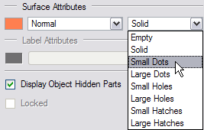

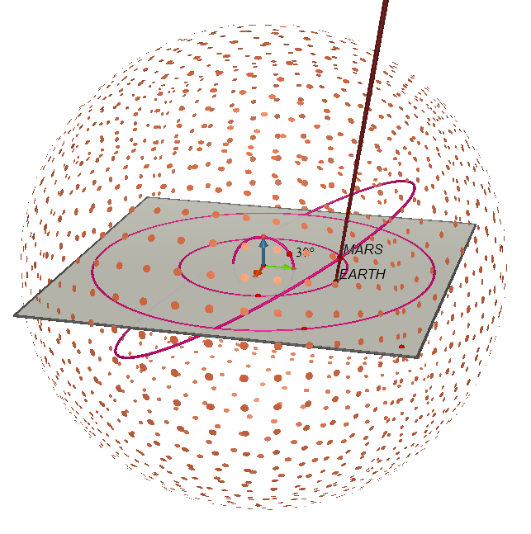

There is also a right-click contextual menu that allows you to change the appearance of objects.
11. Now let’s find the point at the intersection of the ray and the sphere using the Point tool (you can also use the Intersection Point tool). Move the cursor down the ray until the tooltip gives the message below:
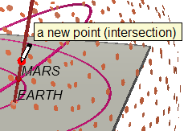

This point represents the observed position of Mars on the celestial sphere.
12. We will use the Trajectory tool to trace the path of this point as EARTH and MARS move.
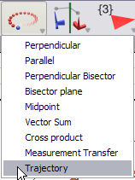

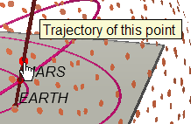

Now click on the Start Animation button and watch what happens!
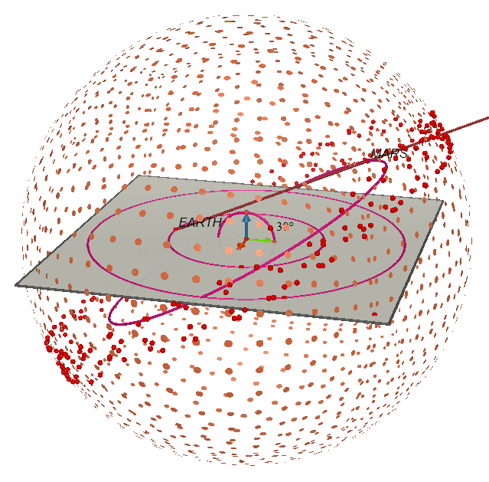

13. The spattering pf red dots represents the observed positions of Mars. To get a clearer picture, let’s hide the celestial sphere (using the right-click contextual menu or the shortcut CTRL-M), slow down both planets (stop the animation, select EARTH and change its speed to 2.5 cm/sec and then select MARS and change its speed to 2 cm/sec), and make the trajectory as long as possible. Right-click on the trajectory and choose the following:
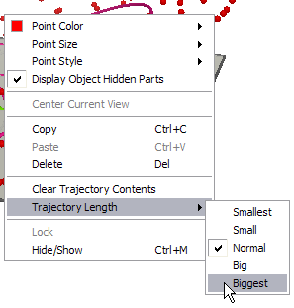

14. Clear the trajectory contents using the same contextual menu and click to start animation once more. This time the path is much easier to interpret:
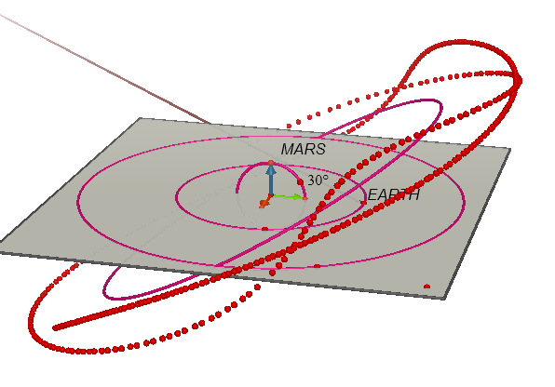

15. Right-click, hold down and drag to view this from different angles. By varying the radius of the two circles, the orbital inclination angle and the relative speed of the two points, you will get different behaviours.
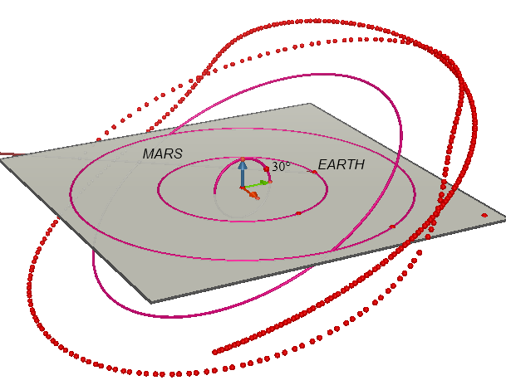

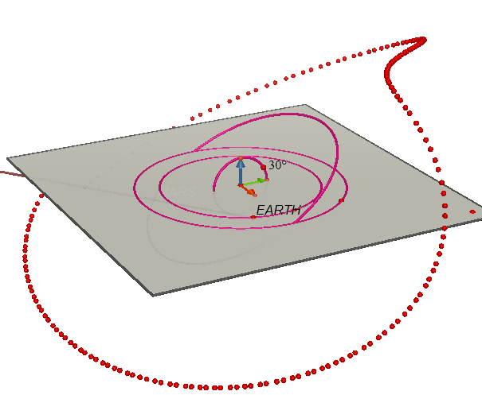

Experiment with your model to find out what sort of motions occur in different conditions.
16. In this model the only variable that has been modelled with roughly appropriate values is the ratio between the orbital speeds of the planets. In order to make a more precise model, here are some changes you could make:
First of all, use the Calculator tool to input the precise ratios for orbital radius and the angle of orbital inclination.
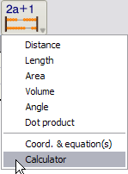

Type in the number for the ratio of the radius of orbits and click on Insert.
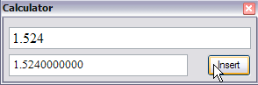

Move the cursor to where you want the result to appear and click to position it.
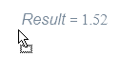
Note that it is displayed rounded to 2 decimal places: use the right-click contextual menu if you want to change its display accuracy.

Select the pointer tool and now click once on the word “Result” and then click again (do not double-click as this will reopen the calculator).. Edit this as follows:
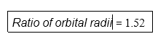
Repeat this to enter the value of 1.85 degrees for the orbital inclination of Mars.
17. Now use the Distance tool to measure the distance between the Earth and the origin.
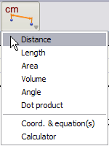

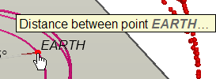

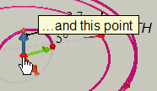

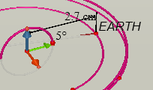

18. We will now use these numbers to calculate the appropriate radius for the orbit of Mars. Select the calculator tool and then click on the measurement.
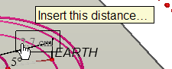

This will appear in the calculator:
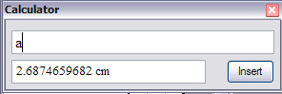

Now type “*” (for multiply) in the calculator.
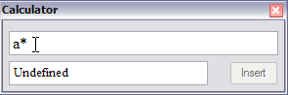

Click on the ratio
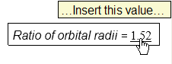

Here is what will appear in the calculator:
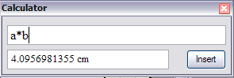

Now click on Insert, move the cursor to where you want to position the result, and click. Edit the text of the result to read as follows:
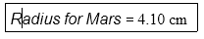

19. Now use the Circle tool to create a circle centred at the origin with this radius.
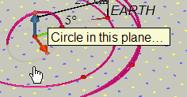

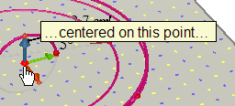

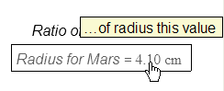

There is now another circle on the base plane
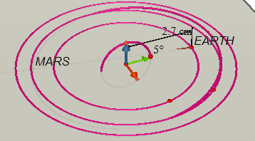

20. At this point, we could repeat everything done previously – or use the Redefine tool! We will redefine the original radius point for Mars to be a point on this circle: this way we do not have to repeat any of the construction.
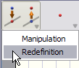

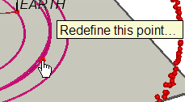
This point is the original radius point for Mars. Click on it and then RELEASE – DO NOT DRAG.
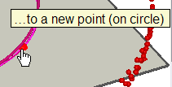
Move the cursor to the new circle and click.
21. Similarly, we can change the orbital inclination to be precisely that of Mars. As in step 6, we could use rotate the circle by the required angle: however, to keep the construction, let’s again do this by using the Redefinition tool.
First of all, drag the point defining the angle on the small circle well out of the way.
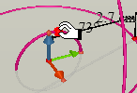

Now use the Rotation tool to rotate the tip of the green base vector around the red base vector:
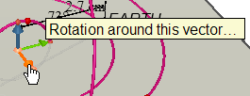

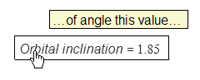

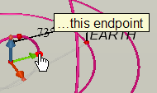

Now use the Redefine tool to identify the old point on the circle with this point.
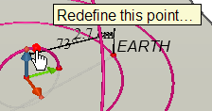

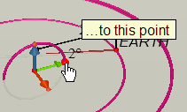

You now have a much more precise model of the motion of the Earth and Mars. Note, however, that the retrograde motion may be much less visible with a smaller orbital inclination.

